YARD WASTE

2025 SCHEDULE & GUIDELINES

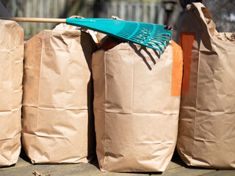

* Must be in brown biodegradable 30 Gallon Yard Waste Bags or tied bundles of small sticks and branches (less than 3 feet long & 3 inches in diameter)
* Limit is the equivalent of 6 bags per household
* Must be placed curbside on your REGULAR TRASH DAY by 6:00 am

WEEK(S) OF 2025:

April 7th & April 21st

May 19th

June 16th

July 14th

August 18th

September 8th

October 6th & October 20th

November 3rd & November 17th

December 15th